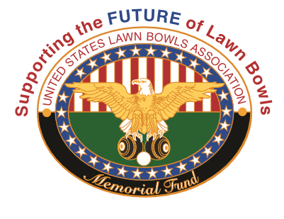
The USLBA Memorial Fund is a NON-PROFIT California Corporation. It is a TAX EXEMPT Public Charity under IRS Code Section 501 C (3) - EIN 74-3196899. ALL CONTRIBUTIONS ARE TAX DEDUCTIBLE

I wish to contribute to the USLBA Memorial Fund in the amount of $__________

My contribution is to be used for the benefit of: (select one or more & $ amount)
General Fund ________________ US Nat’l Championships _______________
US Open ____________________ Team USA ___________________________
North American Challenge (NAC)_____________________________________________

I have provided for a bequest in my Will or Trust (circle one) as follows:
Trustee’s Name: ________________________________________
Phone Number: _________________________________________
Further explanation: _____________________________________

My contribution is in memory of or in honor of:
(print name)_________________________________________________
Please send an acknowledgement of this contribution to:
Name:____________________________________________
Address:__________________________________________
City/State/zip______________________________________

Your Donor Name / Company (print name)
Name:____________________________________
Address:__________________________________
Phone:____________________________________
Email:_____________________________________
Signature:__________________________________ Date:_____________

Please make your check payable to: USLBA Memorial Fund Inc.
Mail to: Norma Goodhart
1502 Lakeside Lane
Huntington Beach, CA 92648
Phone: 714-390-8800 Email: normagoodhart@verizon.net

